Machine A: 10.0.2.7

Machine B: 10.0.2.8

**Task1: Using Firewall**

* Prevent A from doing telnet to Machine B.

Code & result: 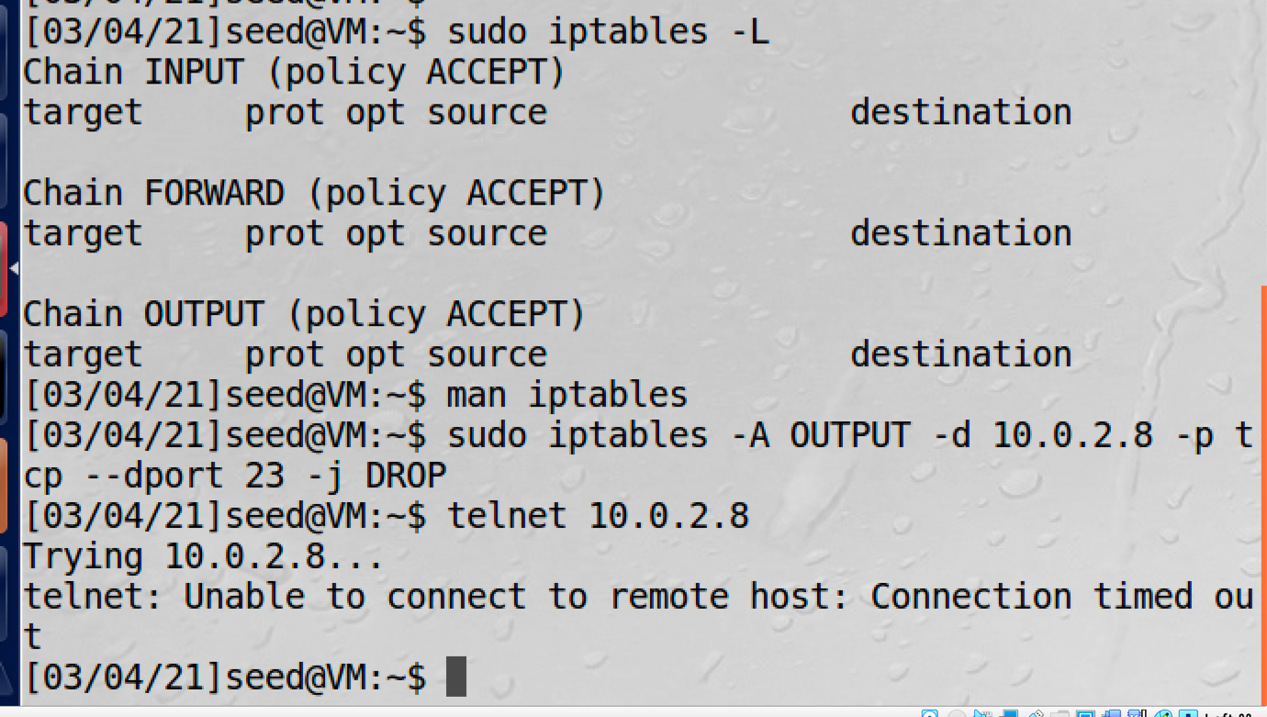

As you can see, I use the command ‘sudo iptables -A OUTPUT -d 10.0.2.8 -p tcp –dport 23 -j DROP’ on machine A to drop all the packets which send form machine A to 10.0.2.8 which is machine B with destination prot of 23. Which means I drop all the telnet packet which send from A to B. After I added this new iptables rule, the telnet command will not work.

* Prevent B from doing telnet to machine A

Code&result: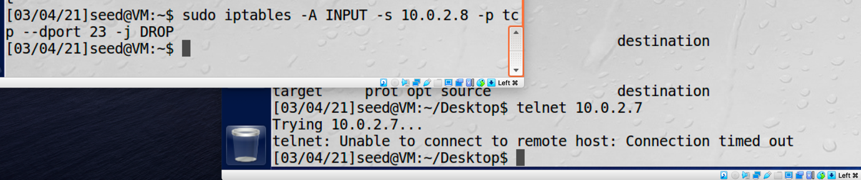

As you can see, I add a new iptables rule to drop all the telnet packets send form machine B to machine A by using the command “sudo iptables -A INPUT -s 10.0.2.8 -p tcp –dport 23 -j DROP”. After added this rule, the telnet command on Machine B will not work.

* Prevent A form visiting an external website.

By using the command “sudo iptables -A OUTPUT -p tcp -d [www.youtube.com](http://www.youtube.com) –dport 80 -j DROP”, I dropped all the http request packets which sending form machine A to request the YouTube websit. Since the YouTube website has multiple Ip address, so the iptables will block them all.

Result:

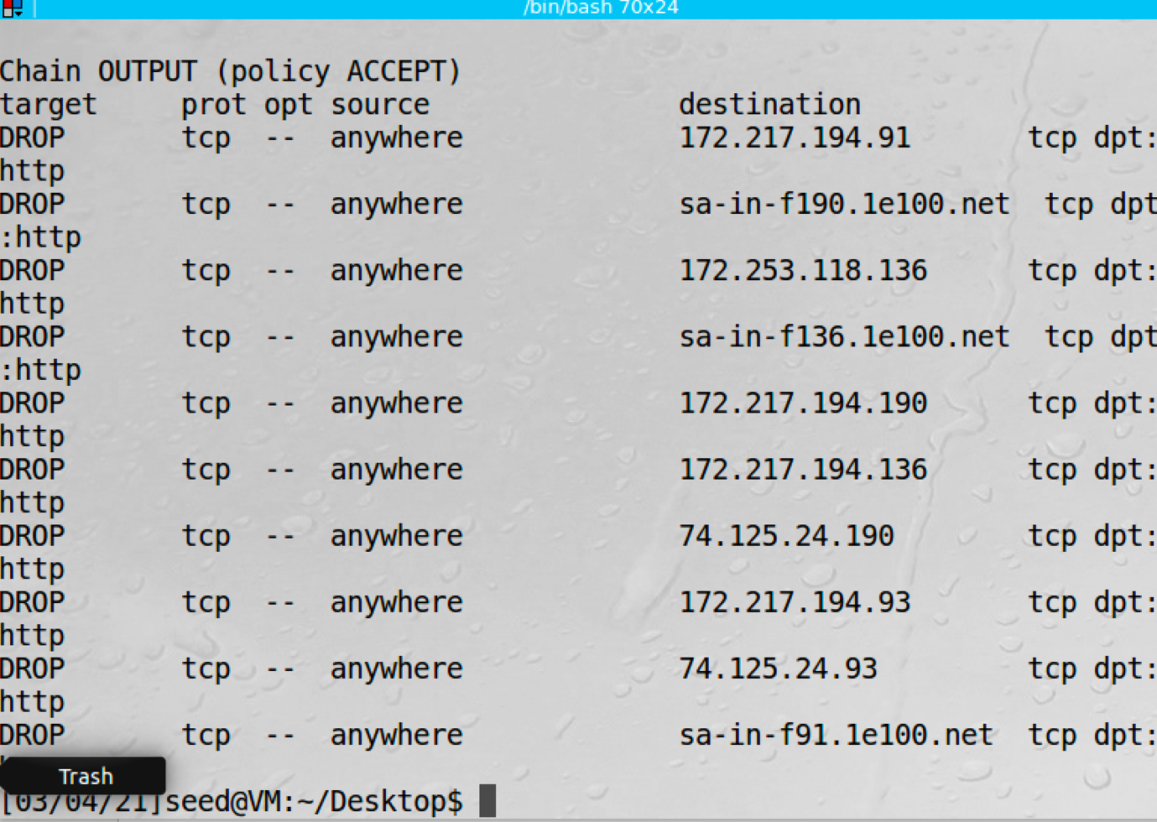

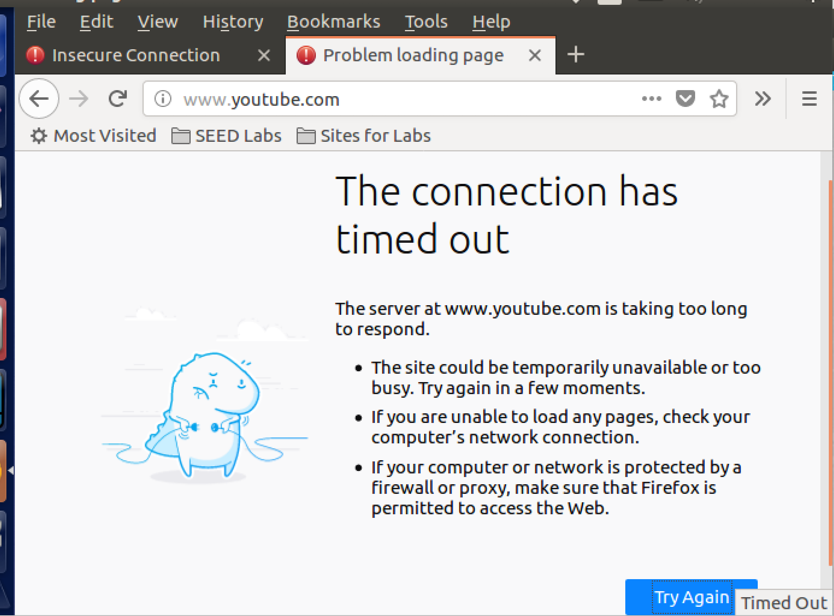

As you can see, after added the iptables rule, machine A cannot visit the youtube website.

Task2: Implementing a Simple Firewall

* In order to implement a new firewall rule, a Loadable Kernel Module should be coded which can directly implemented into the kernel process. The LKM file should be coded in C language. I coded 5 different file in order to implement these five different rules.
  + Rule 1:

Code:

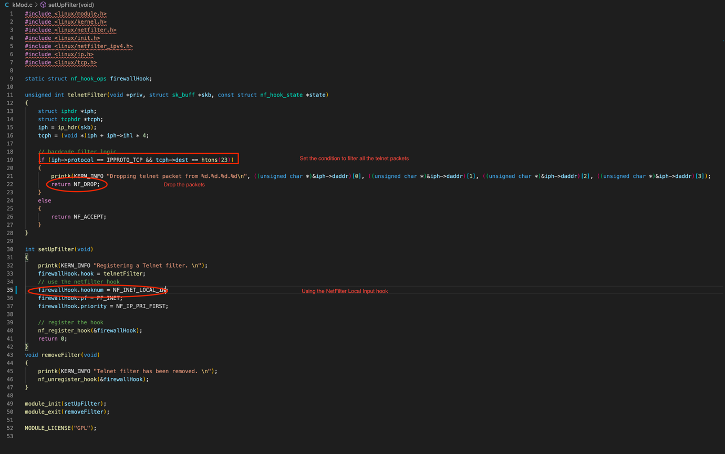

After finished coding, I create a Makefile to order to compile this file to a LKM. 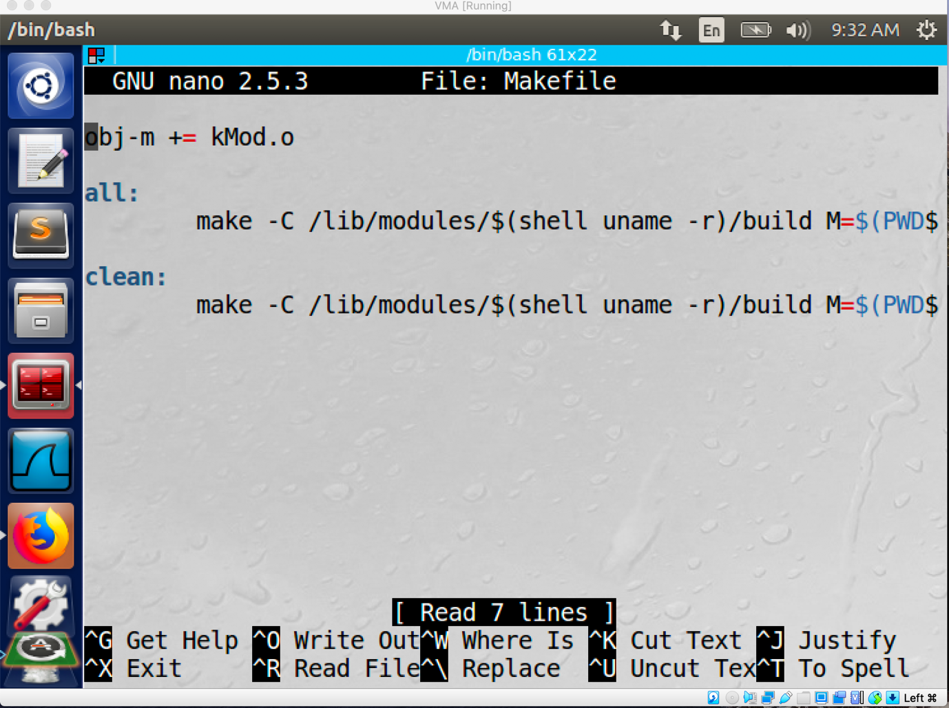

Then I use the command ‘make’ to create the kMod.ko file which is the LKM

File.

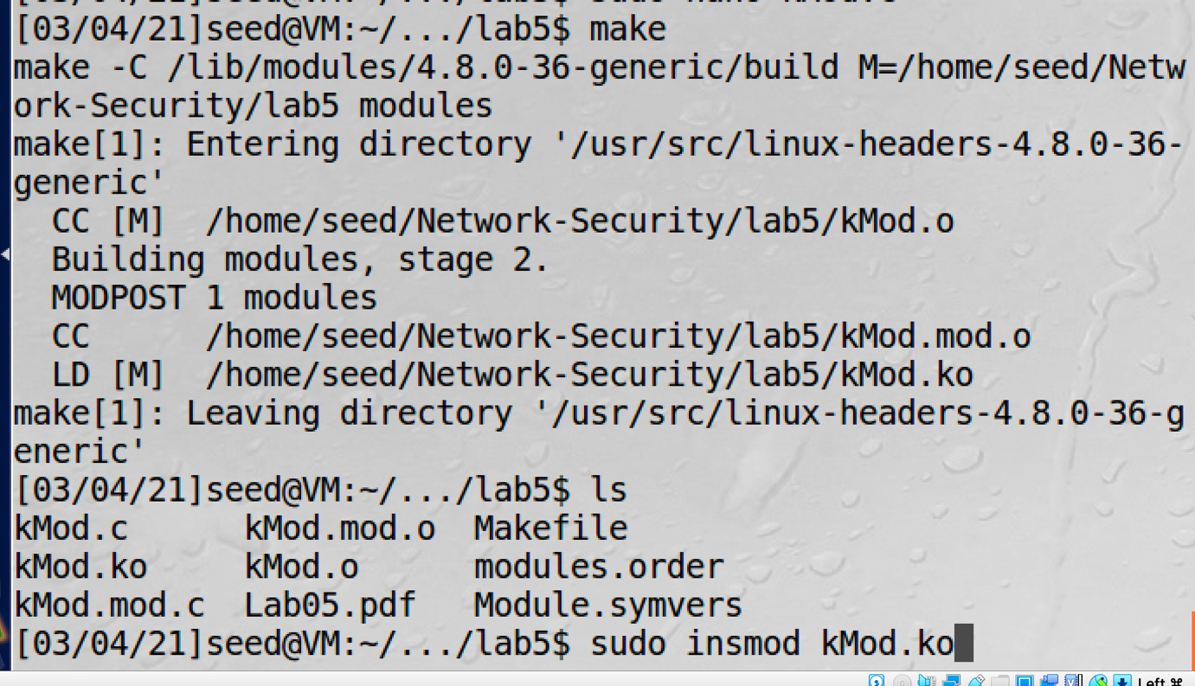

After “make” command I use the command “ sudo insmod kMod.ko” to insert this custom module to the kernel. 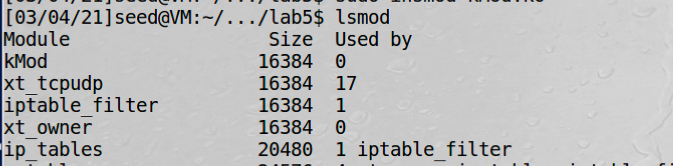

After loaded the module, the telnet command will not work.

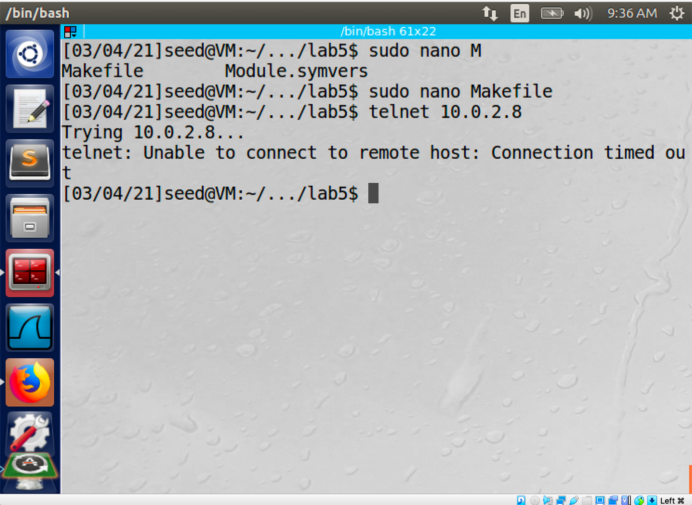

Then I use the command “dmesg | tail” to check the log.

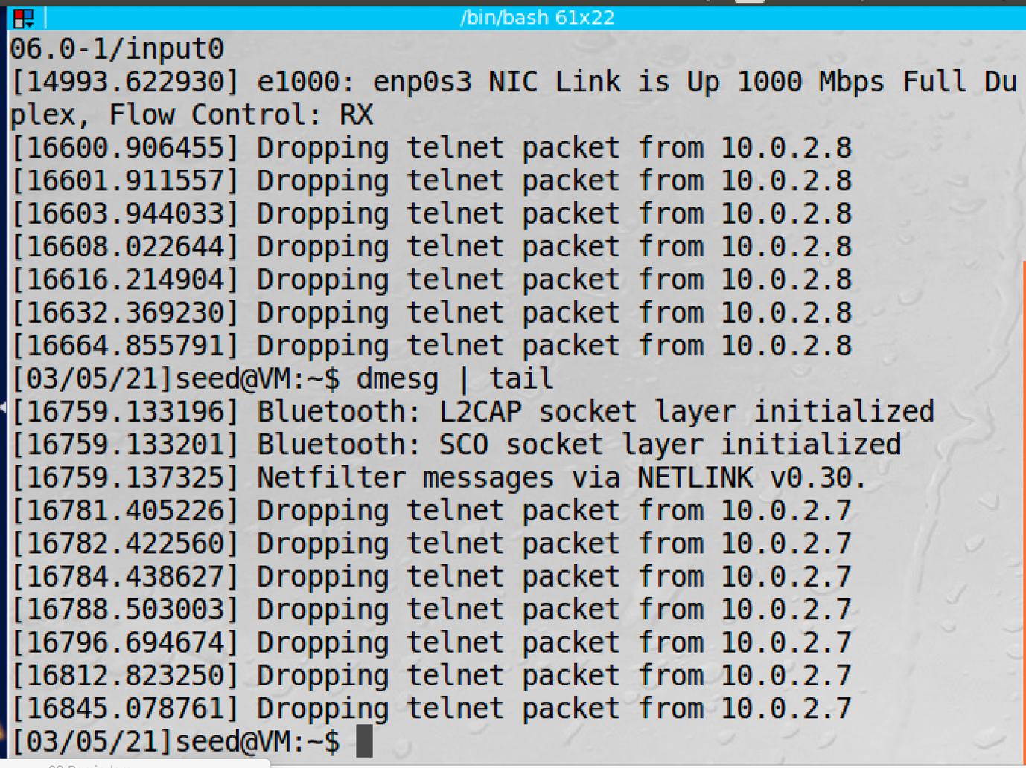

* + Rule 2:

The rule number 2 is to filter the HTTP request sending out from A to 157.240.13.35 which is the ip address for facebook website.

Code: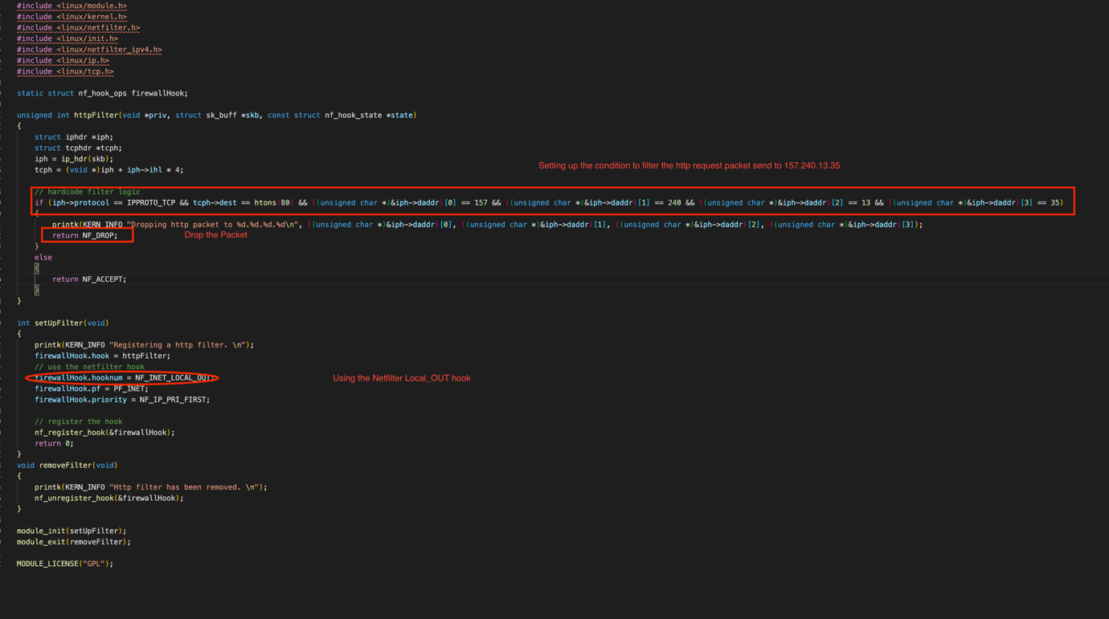

Then I repeat the same procedure for rule 1 to load this module to the kernel.

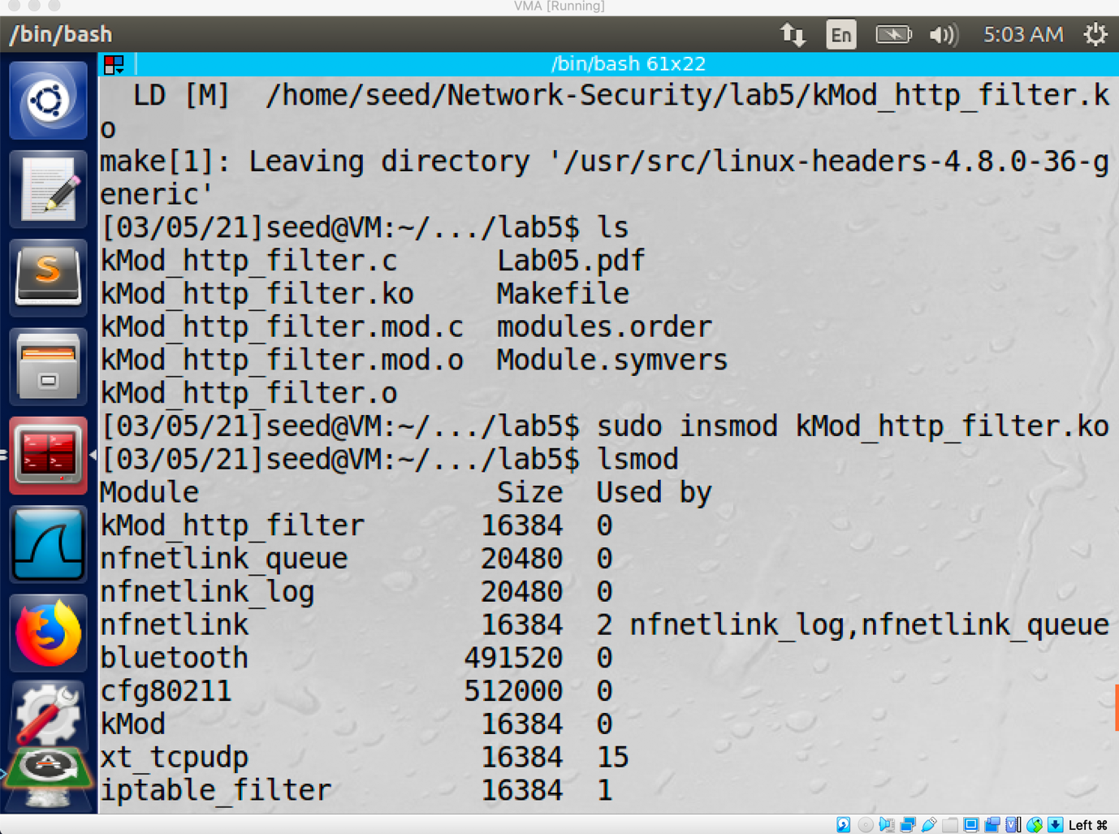

After the module is loaded, the facebook website is not reachable.

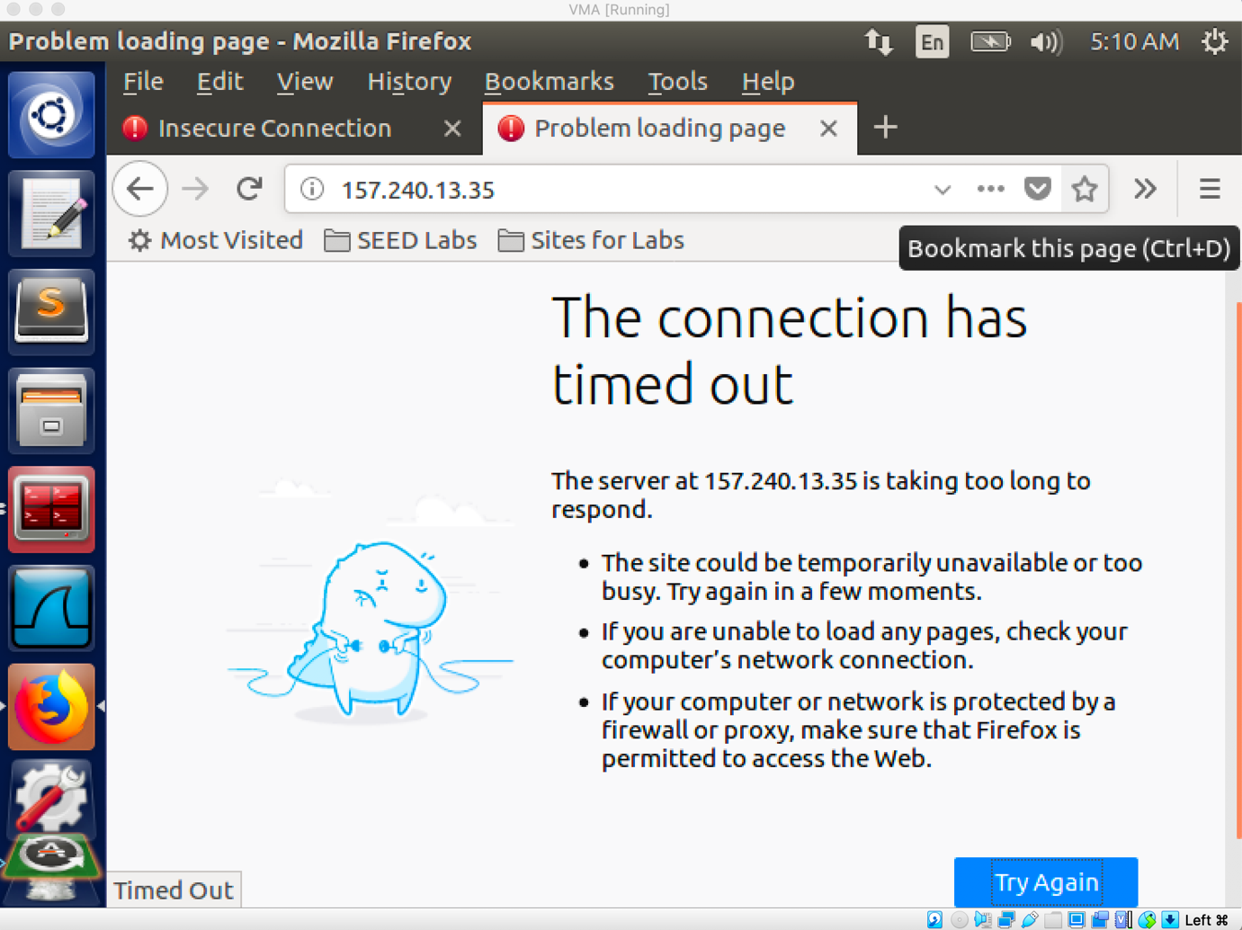

The log message is:

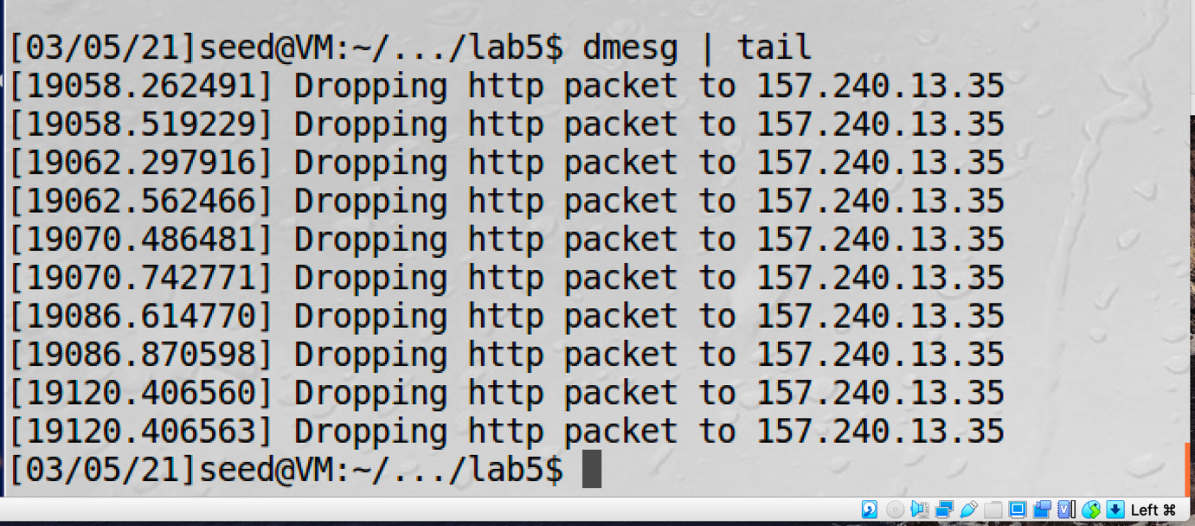

* + Rule3:

I create rule 3 to prohibit the ping request for machine A

Code:

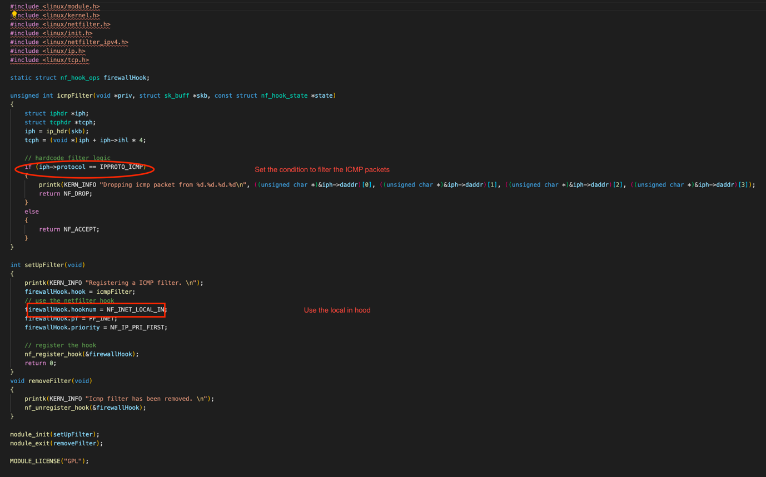

After the same procedure to load this module, all the ping request to A will not be successful.

Result:

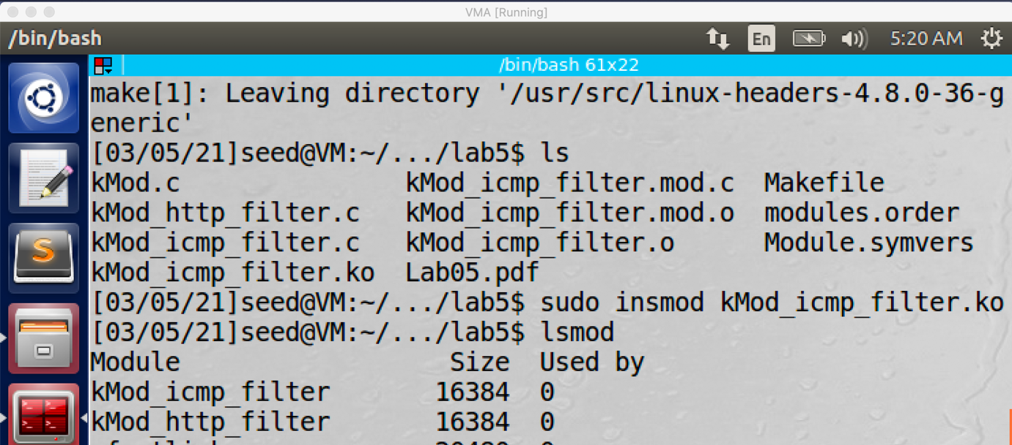

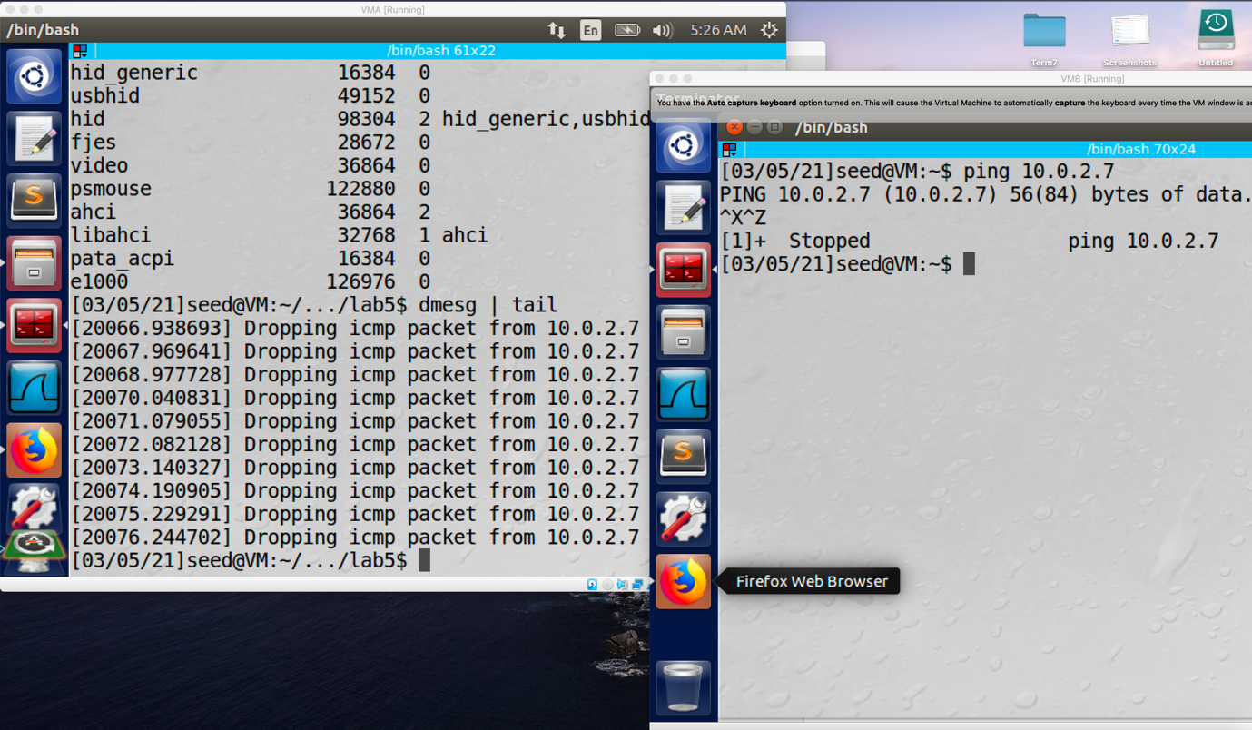

* + Rule4:

I create rule 4 to only allow then ssh request from 10.0.2.8.

Code:

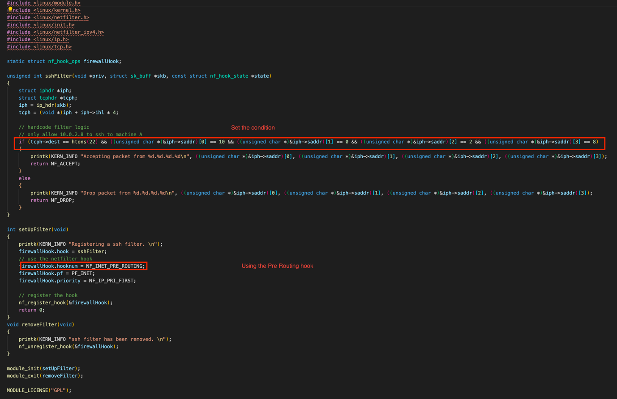

Result:

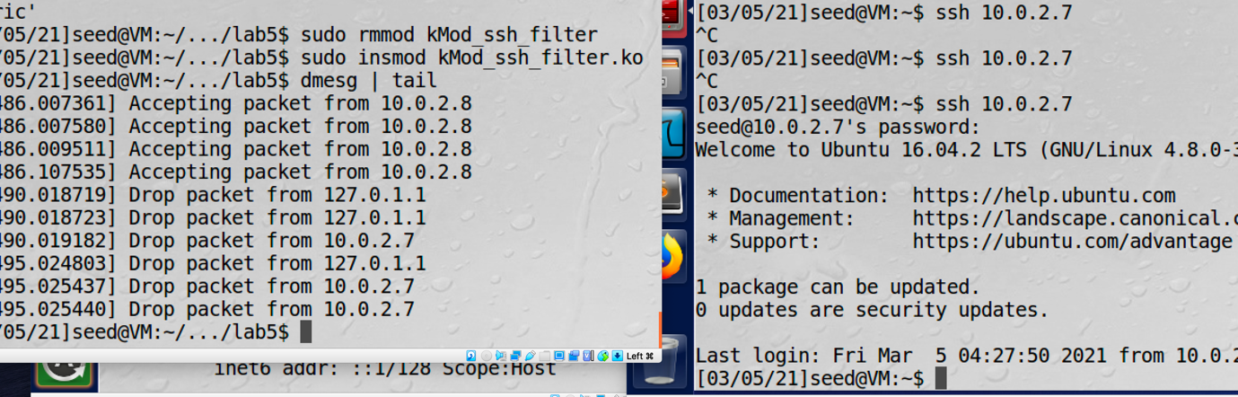

* + Rule 5:

I use the rule 5 to edit all the source ip address to 1.2.3.4.

Code:

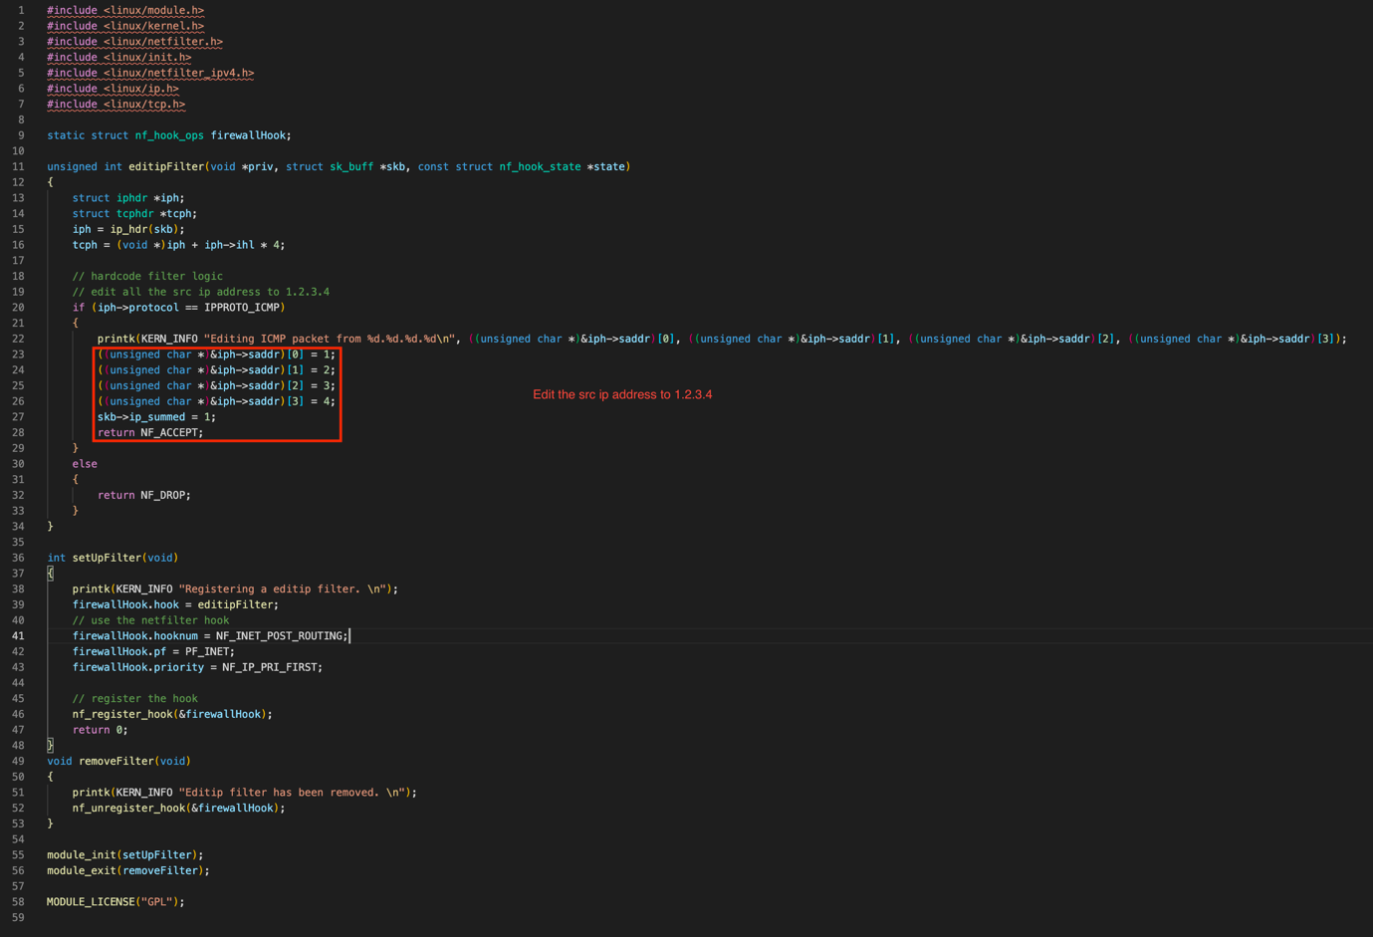

Result:

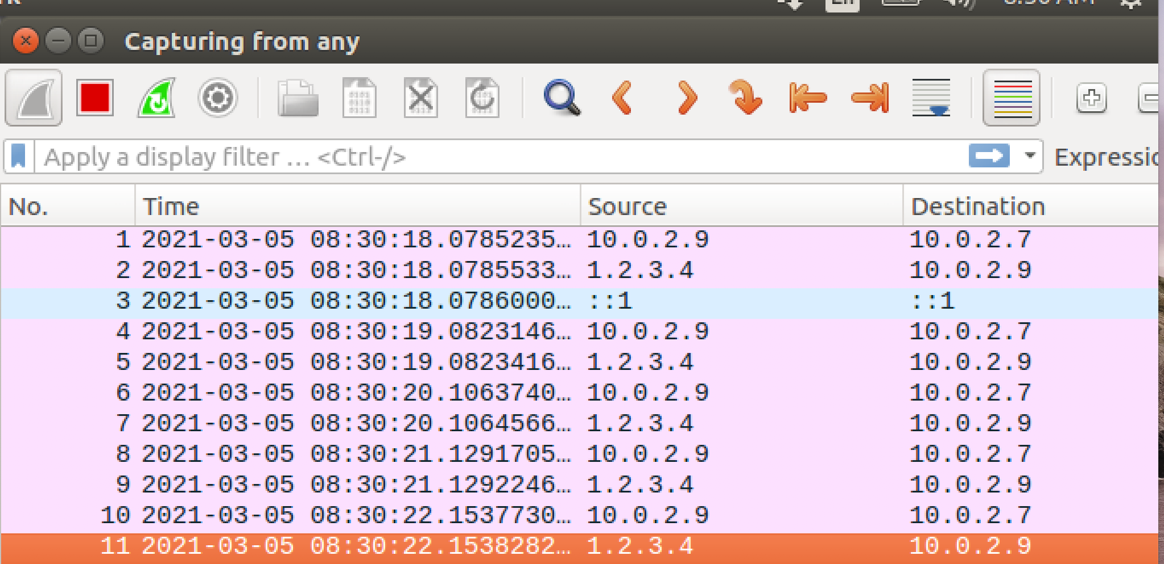

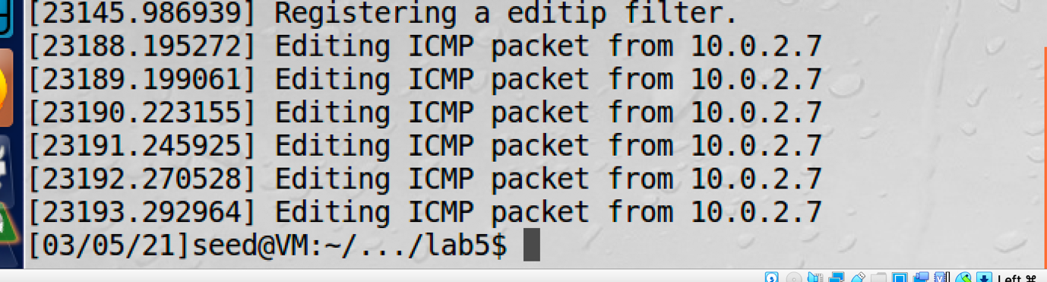

Task 3: Evading Egress Filtering

* 3a:
  + Step1:

I add a new iptables rule to block all the telnet request to 10.0.2.8 which is machine B by using the command “sudo iptables -A OUTPUT -p tcp -d 10.0.2.8 –dport 23 -j DROP”. After this new rule is added the telnet command will not work.

* + Step2:

In order to contact machine B, I use the command “ssh -L 8000:10.0.2.8:23 [seed@10.0.2.8](mailto:seed@10.0.2.8)” to create a ssh tunnel which liked 8000 port to the 23 port of machine B. After the tunnel is created, I am able to telnet the machine B by telnet the localhost port 8000:

* + Result:

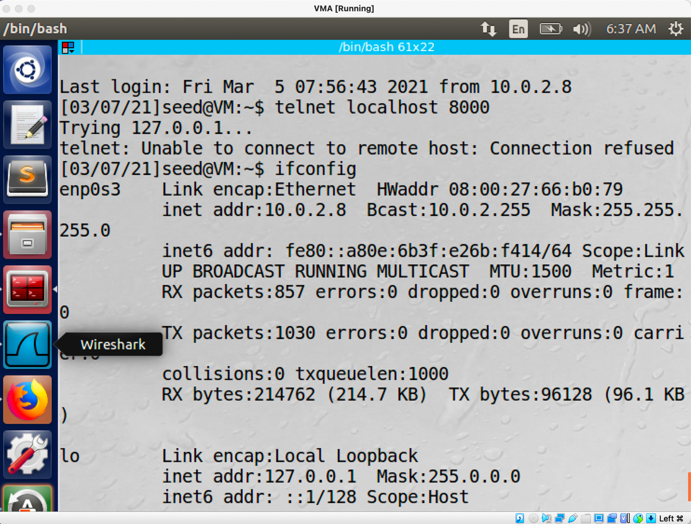

* 3b:
  + Step1:

I use the command “sudo iptables -A OUTPUT -p tcp -d 74.125.24.93 –dport 80 -j DROP” to add a new iptables rule to block the machine A to visit 74.125.24.93 which is one of the ip address of google. After the rule is added, machine A is not able to visit that website.

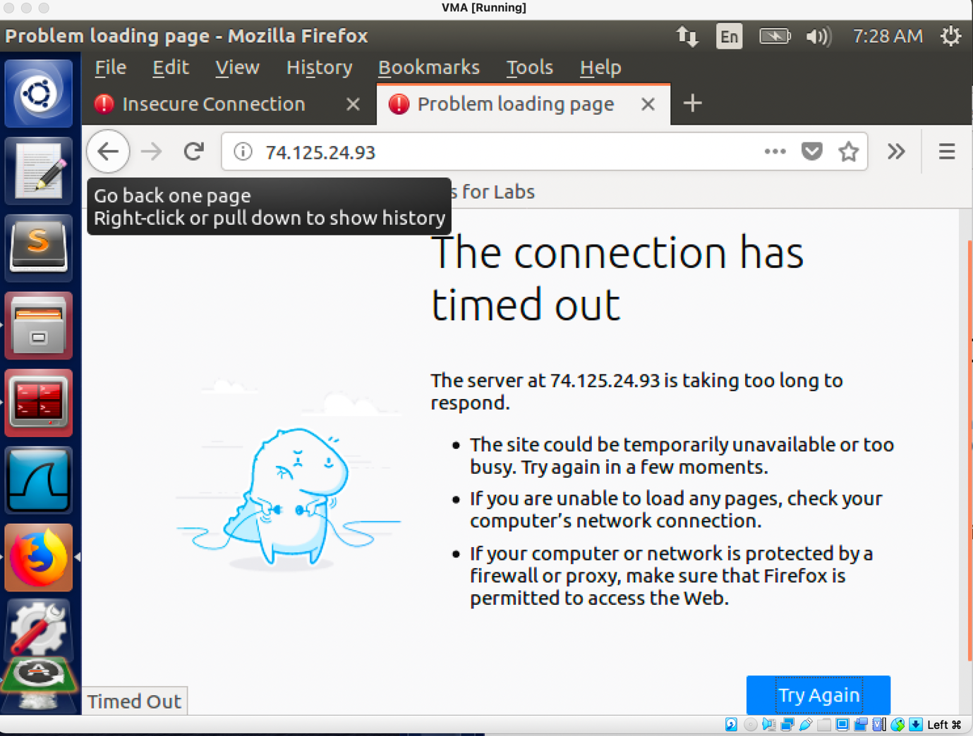

* + Step2:

I set up the Firefox proxy to help the machine A to reach the website.

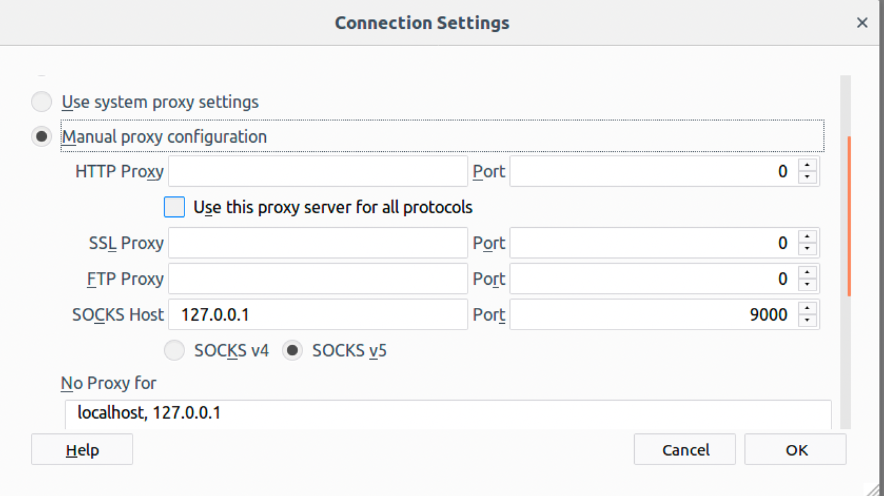

After I set up the proxy, machine A are able to reach the google website.

Result:

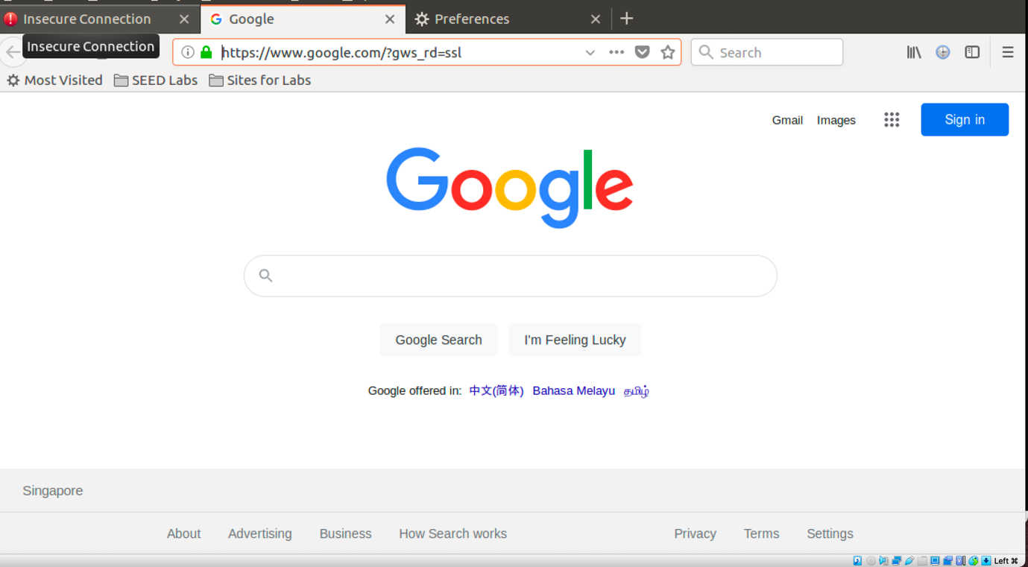

* Task4: Evading Ingress Filtering
  + Step1:

Initially, I added two iptables rules to block machine B from accessing machine A’s port 80 and 22.

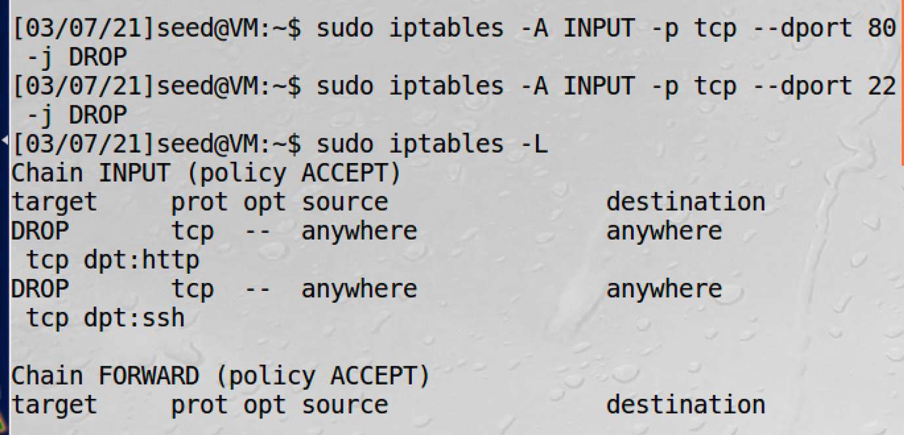

Under this condition, machine B are not able to access the secret server at machine A.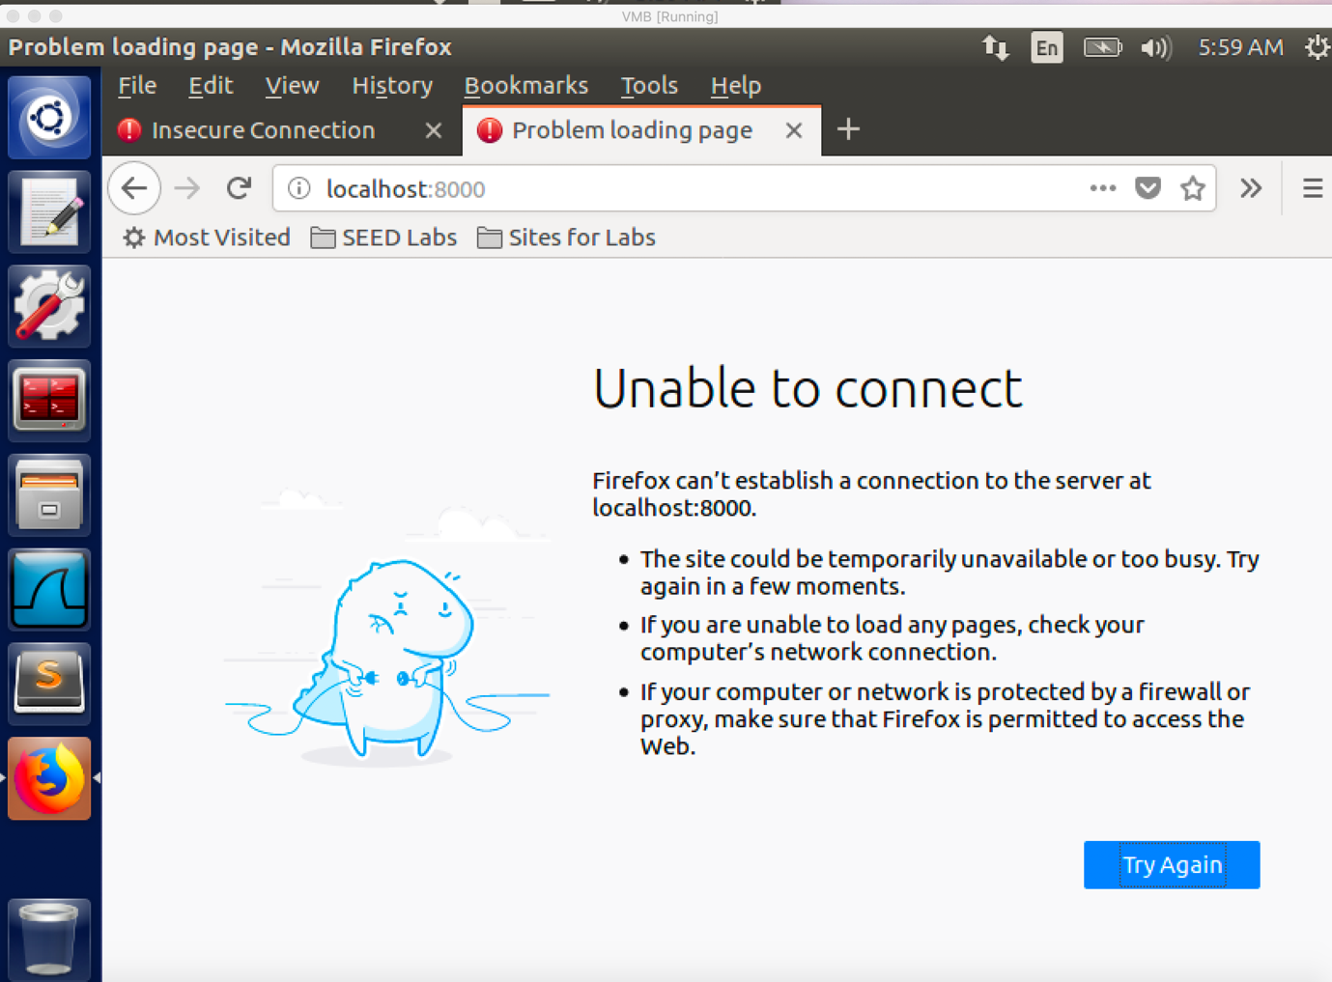

* + Step2:

I created the reverse tunnel at machine A in order to let machine B to access the secret sever at machine A by using the command “ ssh -R 8000:localhost:80 [seed@10.0.2.8](mailto:seed@10.0.2.8)”. I connected the local port 8000 of machine B to port 80 of machine A. Under this condition machine B is able to access the secret server.

Result:

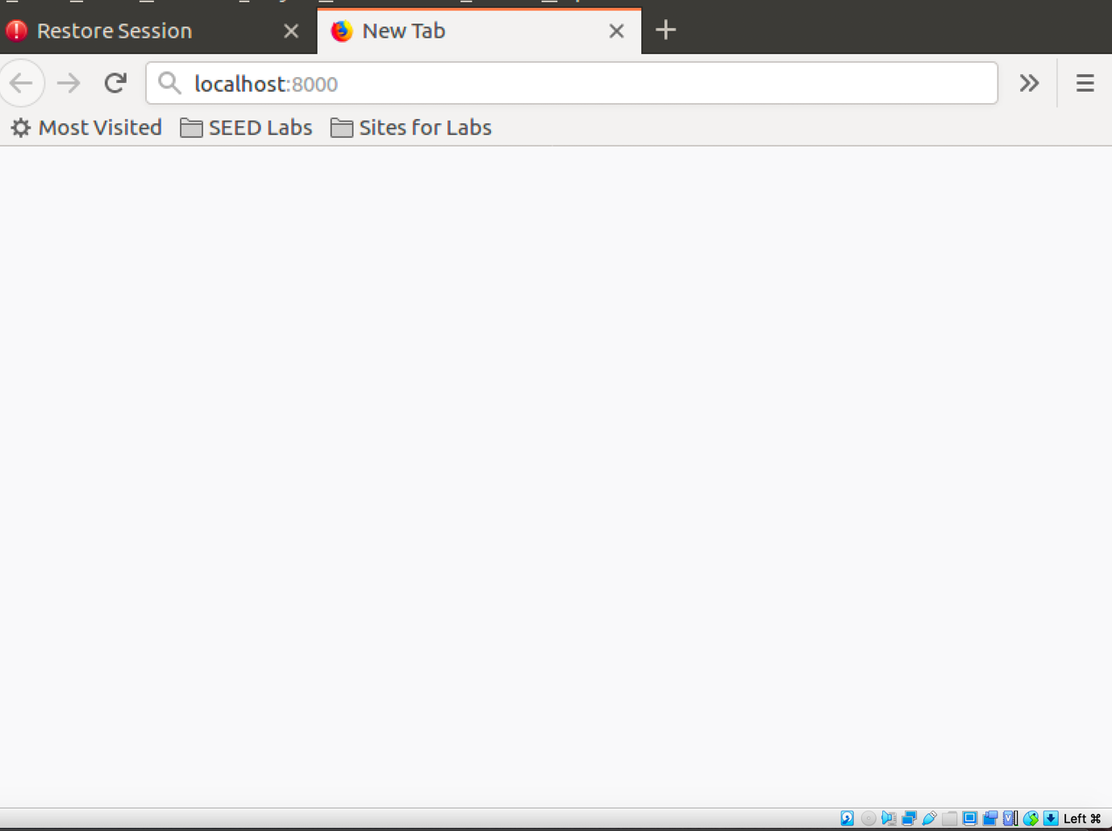

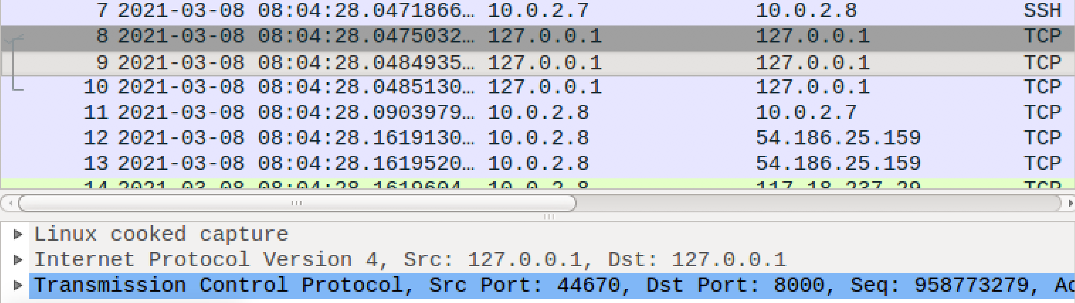

As you can see, the destination of the TCP packet is sending to port 8000 and machine B is able to access the secret server.